**Добридник Світлана ІП-02**

**Варіант 18**

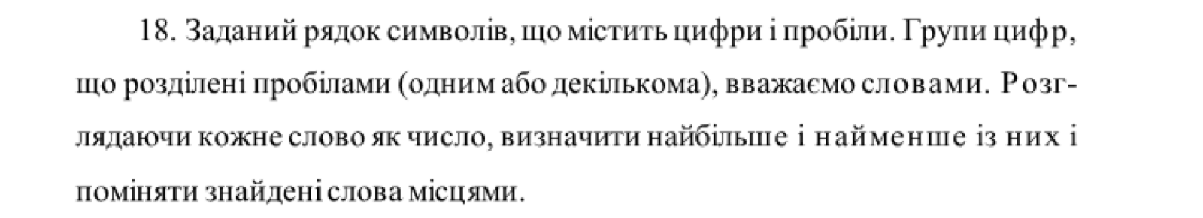

**Блок-схема**

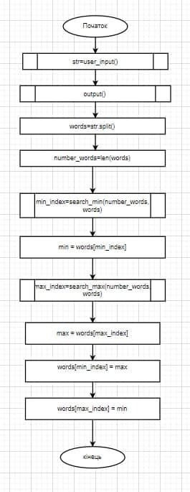

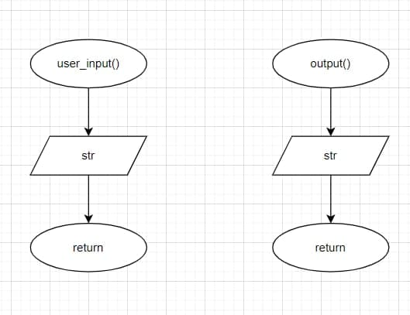

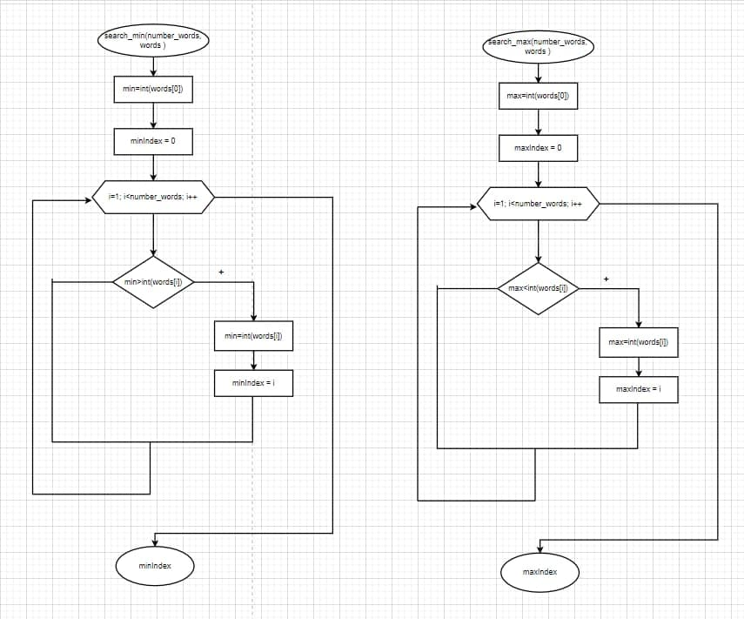

**Код на Python:**

def user_input():

str=input('input your string: ')

return str

def output():

print (str)

def search_min(number_words, words ):

min=int(words[0])

minIndex = 0

for i in range (1, number_words):

if min>int(words[i]):

min=int(words[i])

minIndex = i

return minIndex

def search_max(number_words, words ):

max=int(words[0])

maxIndex = 0

for i in range (1, number_words):

if max<int(words[i]):

max=int(words[i])

maxIndex = i

return maxIndex

str=user_input()

output()

words=str.split()

number_words=len(words)

print("number of words: ", number_words)

min_index=search_min(number_words, words)

min = words[min_index]

print("min: ", words[min_index])

max_index=search_max(number_words, words)

max = words[max_index]

print("max: ", words[max_index])

words[min_index] = max

words[max_index] = min

print("str: ", words)

**Перевірка:**

